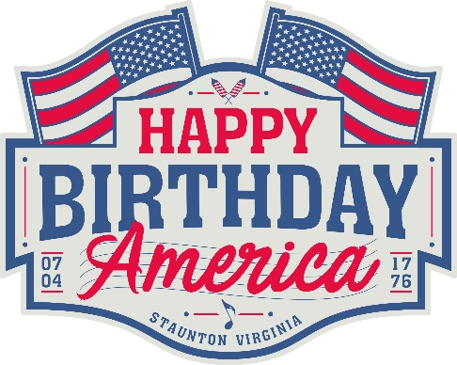

**Happy Birthday America (a non-profit organization)**

**FOR IMMEDIATE RELEASE**

**Point of contact: Jeff Ishee, 540-424-4445 jeffishee@gmail.com**

**Back to the ballfield**

***New organization will return Staunton 4th of July festivities to Gypsy Hill Park baseball field***

*NOTE: (broadcast version on last page)*

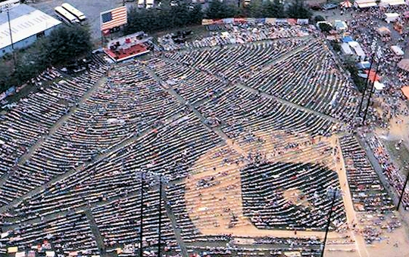December 4, 2017

*STAUNTON, VA* – A long-standing Staunton tradition is under new leadership and will be expanding the city’s annual 4th of July festivities by returning to the baseball field at Gypsy Hill Park’s John Moxie Stadium.

“Happy Birthday America,” led by cousins Wil and Langdon Reid along with a core group of community leaders, is assuming responsibility for the popular event. Jeff Ishee, former General Manager of the Rockingham County Fair, will serve as president of the organization. America’s Birthday Celebration (ABC) managed the event for numerous years but elected to dissolve itself after the 2017 celebration. Beginning in 2018, the annual event will be known as “Happy Birthday America” and will be the 49th anniversary since the Statler Brothers started the event.

**It’s all about the people**

"Since this event was born in Staunton in 1970 by the Statlers, it has organically grown and turned into the kind of event that the community is excited about and wants to be involved in,” said Langdon Reid. “That is the vision of this HBA committee; to have fun, entertain, celebrate and all the while the local charities, churches, civic organizations and businesses can benefit from. It's all about the people and the people certainly showed their overwhelming support in 2017's successful celebration."

The Reid cousins say they are happy to be involved in an event created by their fathers nearly 50 years ago. "We've seen firsthand how to grow it and make it better each year, and we're so excited to be a part of it to help bring those good times and memories back for so many," added Langdon.

"We are so honored and encouraged by the overwhelming support for Wilson Fairchild to return to the stage for Happy Birthday America in 2018,” remarked Wil Reid. “We will headline the event with our band and deliver a high energy show that Staunton became well known for years ago. We have a lot of friends in Nashville and the music business. Our plan is to invite some of our incredibly talented friends to Staunton and have them share their talents in our hometown. In months to come, we'll see what happens!"

**Why the move back to the baseball field?**

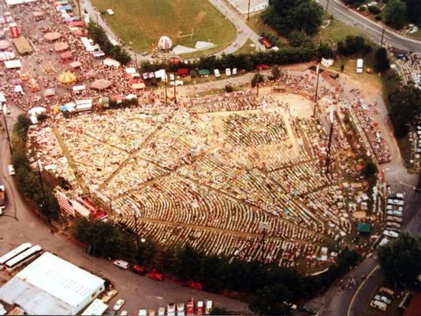"It was essential for us to bring the concert back to the baseball field,” observed Wil. “We grew up with all of our 4th of July memories centered around that ballfield. And with the help and support of some great folks with the City of Staunton, our dream came true!"

The annual 4th of July celebration has a long history in Staunton’s Gypsy Hill Park. Originally organized by the Statler Brothers in 1970, the event was known as Happy Birthday USA through 1994 and then America’s Birthday Celebration (ABC) from 1995 to 2017. It continues to attract thousands of spectators each year. Hometown folks as well as tourists from across the United States are treated to a patriotic and colorful parade along with good music, food, and fireworks in a family atmosphere.

**City enthusiastic; glad to see the tradition continue**

“The City of Staunton has been fortunate to enjoy the benefits of homegrown and well-known talent for our July 4th festivities,” remarked Staunton Mayor Carolyn Dull. “We’re grateful to the ABC committee for their hard work and accomplishments, and they will always be remembered as the group that supported the Statler Brothers’ vision, making Staunton the place to be on Independence Day.”

Mayor Dull expressed enthusiasm about the future of the event. “We’re thrilled about the infusion of new energy and ideas through Happy Birthday America and Wil and Langdon Reid, said Dull. “It’s fitting – and exciting – that the sons of two Statler Brothers now continue the tradition. We have great expectations and are looking forward to a sensational Fourth of July celebration in 2018.”

“Our newly formed board of directors and key volunteers are eager to take the reins of this popular event,” said Happy Birthday America president Jeff Ishee. “We have assembled a group of talented and highly motivated individuals to serve as directors and committee members for the new organization.”

Happy Birthday America has established a web presence at [www.happybirthdayamerica.org](http://www.happybirthdayamerica.org). Registrations for parade entries, sponsorships, vendors and food concessions for the 2018 event will begin on February 1, 2018.

**Broadcast version:**

A summertime tradition in Staunton is making a big move next year. The annual 4th of July festivities in Gypsy Hill Park are moving back to the ballfield. A new organization will oversee the event, which was started by the Statler Brothers 48 years ago on the baseball field at John Moxie Stadium. The new group is being led by Wil and Langdon Reid who are sons of Statler Brothers Harold and Don Reid. Former manager of the Rockingham County Fair Jeff Ishee has been named as President. Starting in 2018, the July 4th celebration will be known as Happy Birthday America. Officials say the move back to the ballfield at is part of a strategic change to bring more people to a family-friendly, patriotic event. The new event web site is happybirthdayamerica.org.

*Interviews available by contacting:*

*Wil Reid: 540-255-5557*

*Langdon Reid: 540-569-6542*